**Weidmuller Ltd. Canada Opens New Calgary Office**

**to Strengthen Presence in Western Canada**

**June 19, 2025 – Markham, ON** – [Weidmuller Ltd. Canada](https://www.weidmuller.ca/en/index.jsp) is pleased to announce the opening of its new office in Calgary, Alberta—marking a significant milestone in the company’s ongoing national expansion. Strategically located in Southeast Calgary, the new facility will serve as Weidmuller’s regional hub for Western Canada, supporting operations across British Columbia, Alberta, Saskatchewan, Manitoba, Yukon, Northwest Territories, and Nunavut.

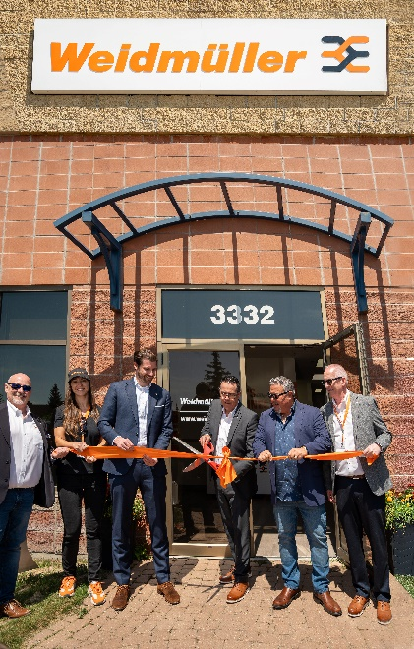

“For the past five decades, our Canadian headquarters in Markham, Ontario has supported customers across the country,” said **Gary Martins, Managing Director – Canada**. “Now, the time is right to establish a dedicated presence in Western Canada. This region has long been a strong market for us and continues to show tremendous potential. Opening this new office reflects our ongoing commitment to the West and represents an exciting step forward in deepening our relationships with valued customers and partners throughout the region.”

Purpose-built to support both customers and employees, the new Calgary office includes:

* A dedicated workspace for the local sales team.
* A Learning Centre designed for hands-on, in-person product training.
* An Automation Lab equipped with the latest technologies, enabling the team to design, implement, and test solutions using both simulation tools and real-world hardware. This collaborative space allows us to tackle complex automation challenges and develop customized solutions tailored to our customers' specific needs.

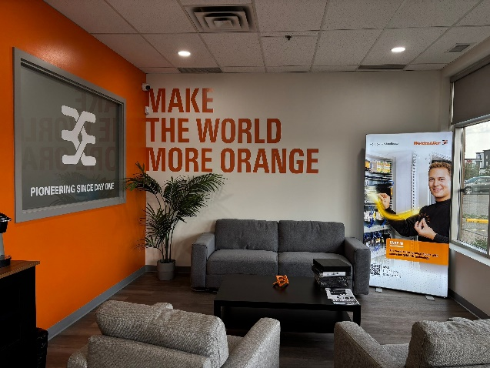 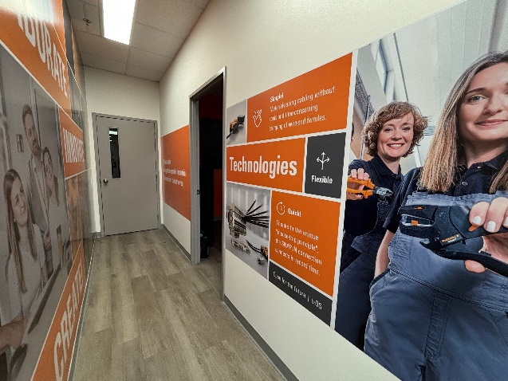

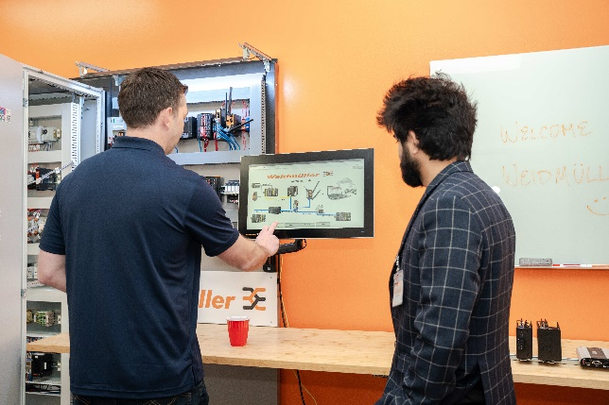 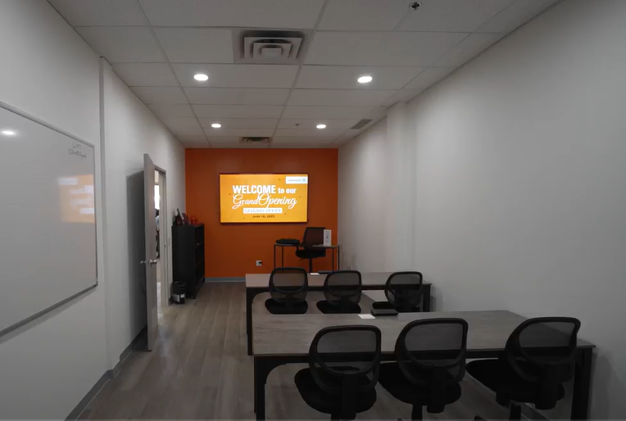

“This investment allows us to be closer to our customers, enabling faster and more effective support,” said **Alfredo Marrello, Regional Sales Manager – Western Canada**. “We’re particularly excited about the Automation Lab, as it highlights Weidmuller’s commitment to delivering innovative, leading-edge automation solutions for our partners.”

The new Calgary office further strengthens Weidmuller’s position as a trusted expert in automation and connectivity, dedicated to innovation and driving customer success across Canada.

The grand opening welcomed over 150 attendees, including distributors, customers, and both current and former Weidmuller employees. The event was marked by the presence of key dignitaries such as Dr. Christian von Toll, Chief Sales Officer of the Weidmüller Group; Lukas Kirstgen, Vice President at the Canadian German Chamber of Industry and Commerce Inc.; Nathan Neudorf, from Government of Alberta and Thomas E. Smith, from Government of Alberta. Their participation, along with that of valued stakeholders, underscored the importance of this new office to the region and to Weidmuller’s continued growth in Canada.

As part of the celebrations, Weidmuller proudly dedicated its new Learning Centre to the late Terry Hodgson, former Vice President of Weidmuller Americas. A respected leader and mentor, Terry served the organization for over 20 years in various leadership roles. His dedication and passion left a lasting impact and continue to inspire those who had the privilege to work with him.

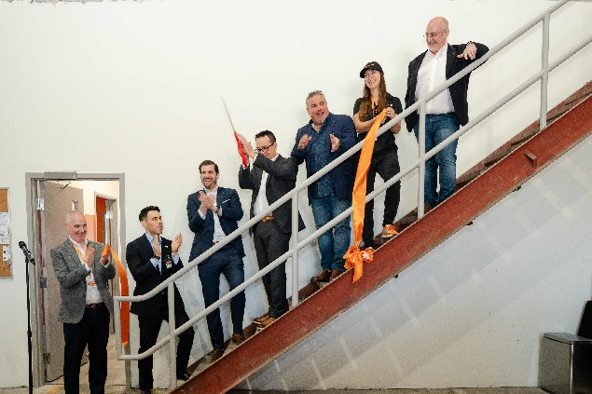 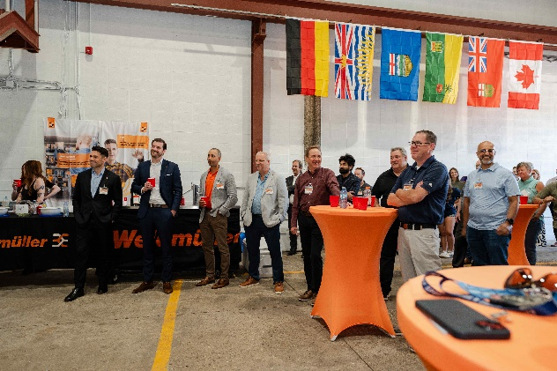

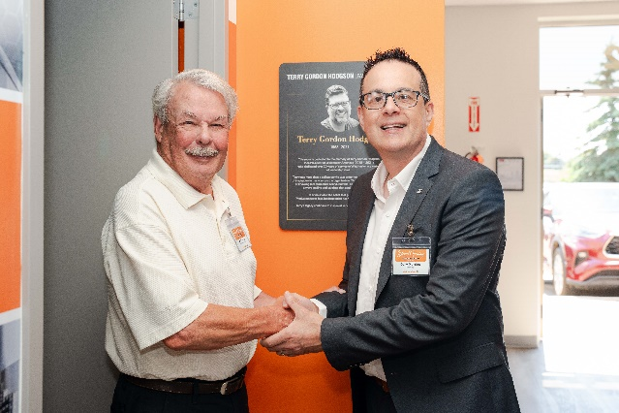 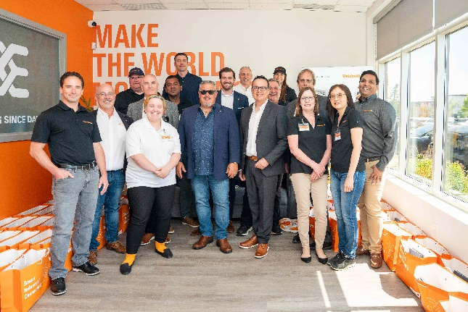

**About The Weidmüller Group**

Smart Industrial Connectivity: Electrification, automation, digitalisation, electrical connectivity and renewable energies – markets in which Weidmüller feels right at home. The family-owned company established in 1850 has production facilities and sales companies in over 80 countries. As a global player in electric connection technology, Weidmüller achieved a turnover of more than one billion euros in the 2023 financial year with around 6,000 employees worldwide - around 2,000 of whom work at the company's headquarters in Detmold, in the heart of East Westphalia-Lippe, Germany. What Weidmüller lives by: [Diversity with respect](https://www.weidmueller.com/int/company/our_company/who_we_are/index.jsp#wm-1246253).

Technologies and engagement for a liveable future - Weidmüller demonstrates how it approaches the topic of sustainability in its interactive [sustainability brochure](http://www.weidmueller.com/sustainability-brochure).