Weidmüller: A Journey of Innovation and Excellence!
Celebrating 50 years in Canada and 175 years globally.

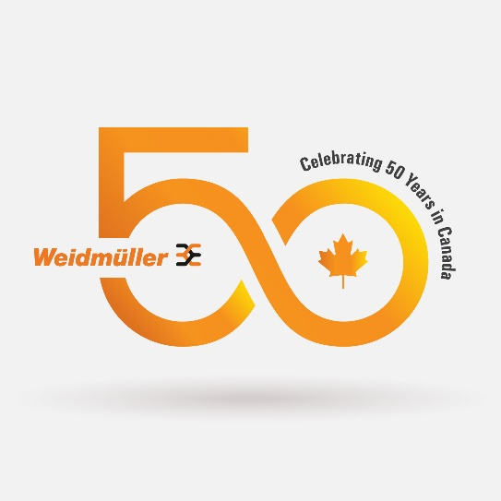

June 13, 2025 – Markham, ON – The year 2025 marks a truly momentous occasion for Weidmüller as the company celebrates not only 50 years of operations in Canada but also its 175th global anniversary — an extraordinary achievement few companies can claim.

Weidmuller Canada’s journey began in 1975, as Weidmuller Terminations Ltd., operating from a modest, warehouse-style office. The company initially focused on supplying the renowned SAK Series Terminal Blocks and DIN Rail, laying the groundwork for a legacy of reliability and innovation.
A major milestone came on May 12, 1986, with the ground-breaking ceremony at 10 Spy Court, Markham, a site that proudly remains Canadian headquarters to this day.

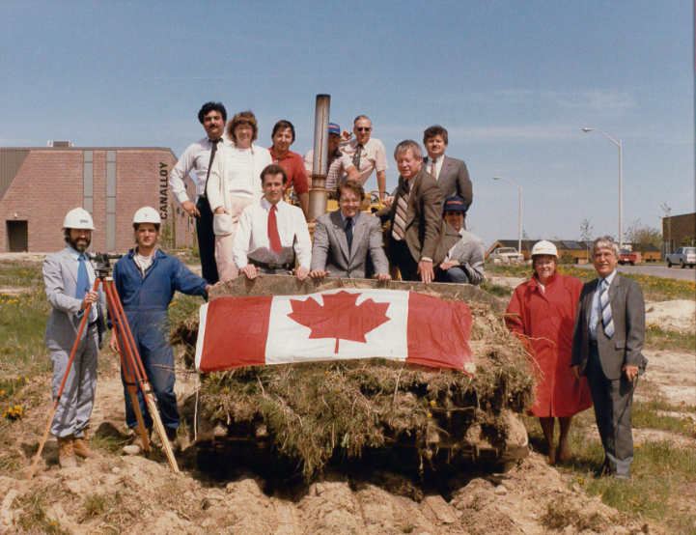
Reflecting on the company’s journey, Gary Martins, Managing Director – Canada, shared:
“From our humble beginnings to becoming a trusted leader in cabinet products, field device connectivity, and automation solutions—both hardware and software—our growth has been fueled by strong customer partnerships, dedicated employees, continuous innovation, and a resilient foundation built on commitment and expertise.”

From that first step in 1975 to the continued growth today, Weidmuller Canada has remained true to its pioneering spirit—connecting people, systems, and technology across industries for nearly five decades.

Following is Weidmüller Canada timeline highlighting key milestones over the past five decades. Experience the full journey through our interactive presentation here.

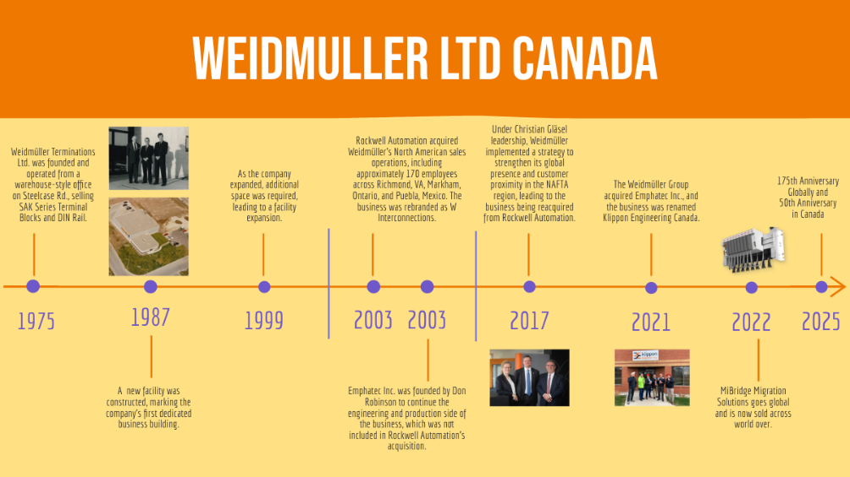

From OEM machine builders, process industries, wind turbines, custom production lines, railway technology, integrators, panel builders, EPC’s, and new energy, Weidmüller’s products and solutions deliver reliable connections wherever they are used. By enabling the seamless transmission of energy, signals, and data across a broad range of industries, they have become essential in an increasingly connected and automated world.

Dr. Christian von Toll, Chief Sales Officer of Weidmüller Group, said “This legacy is a testament to our relentless pursuit of innovation and commitment to refining our offerings. But our journey doesn't stop here; we continue to push boundaries and drive advancements in electrical connectivity.”

Read Weidmüller Groups 175th Anniversary press release here.

About The Weidmüller Group
Smart Industrial Connectivity: Electrification, automation, digitalisation, electrical connectivity and renewable energies – markets in which Weidmüller feels right at home. The family-owned company established in 1850 has production facilities and sales companies in over 80 countries. As a global player in electric connection technology, Weidmüller achieved a turnover of more than one billion euros in the 2023 financial year with around 6,000 employees worldwide - around 2,000 of whom work at the company's headquarters in Detmold, in the heart of East Westphalia-Lippe, Germany. What Weidmüller lives by: Diversity with respect.
Technologies and engagement for a liveable future - Weidmüller demonstrates how it approaches the topic of sustainability in its interactive sustainability brochure.

